Artist Opportunity
Participate in the Annual Friends’ Expo at Ceres Gallery
July 22 - August 16, 2025

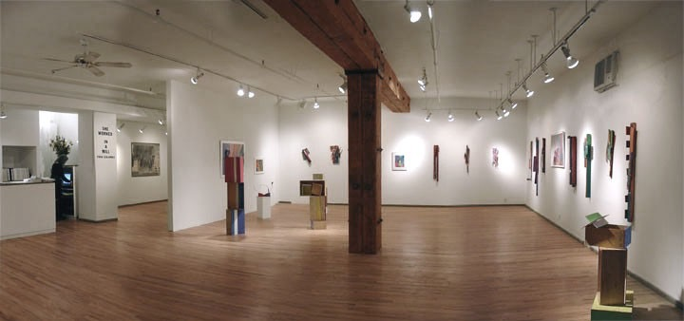

This exhibition is a thank you to ARTIST FRIENDS from Ceres members for a donation of $200. As an ARTIST FRIEND, you will be invited to exhibit a wall piece or sculpture (size limitation) plus a small bonus art work.
If you would like to participate in the Annual Friends’ Expo, please send Ceres your donation of $200 and a completed donation form and become an ARTIST FRIEND. The Friends’ Exhibition is not juried. Ceres is a not-for-profit gallery and your donation will help us continue providing a forum for the enrichment and growth of artists.
Your name will appear on the Friends’ List on the Ceres website http://www.ceresgallery.org (click on Be A Friend) and be in Ceres’ Registry Book with your Artist Statement and your resume.
Exhibition: July 22nd - August 16th 2025
Opening Reception: Thurs., July 24, 6:00-8:00pm

Entry Deadline June13, 2025 to be on the card
Ceres is looking forward to our Annual Friends’ Expo, which will take place July 22 – August 16, 2025.
With an opening reception for the artists and their guests on Thursday, July 24, from 6:00 – 8:00 PM.

We look forward to your participation.
Go to www.CeresGallery.org - Be A Friend - for full details and application
Ceres Gallery 547 West 27th Street, Suite 201 New York New York 10001. 212-947-6100
E-Mail: art@ceresgallery.org - Website: www.ceresgallery.org & Find us on Facebook

2025 Friends Donation Form

Yes! I want to make a difference and support interest and accessibility to new art. Please enroll me as a:

$200 ARTIST FRIEND: Group Exhibition Opportunity, inclusion in yearly Artist Information Registry book (open to public for reference). Receive show announcements and invitations to all exhibition opening receptions and inclusion in Friends of Ceres listing in the brochure and website.

Name________________________________________________________________________________

Address_______________________________________________________________________________

City ________________________________________________ State________________ Zip _________

Phone (day) _________________________ Phone (evening) _______________________________
E-mail address___________________________________________________________

Website ________________________________________________________________

TOTAL AMOUNT ENCLOSED ________________________________________________

All donations are tax-deductible to the fullest extent of the law.
Please make checks payable to Ceres.
Mail checks to: Ceres, 547 West 27th Street, Suite 201, New York, NY 10001.
For further information, please call Stefany Benson, Director:
Phone: 212.947-6100,
Email: art@ceresgallery.org

